**MICROSOFT GRAPH HISTORICAL LOAD TESTING DOCUMENT**

**Table Name: ACCESS_CARDS**

Snowflake Row Count: 27765

Historical Export Row Count: 27765

Column Matching?: Yes

Value Matching?: Yes

**Snowflake Records:**

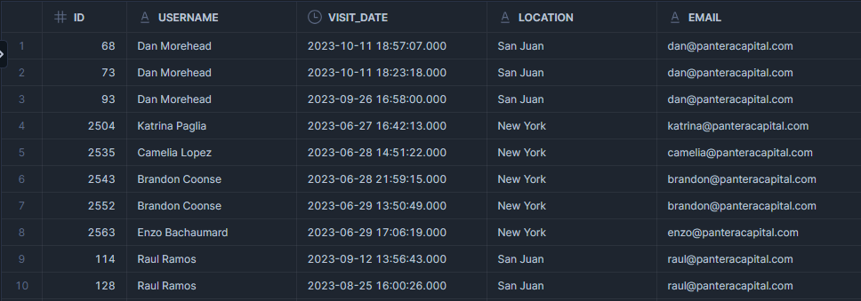

**Historical Export Records:**

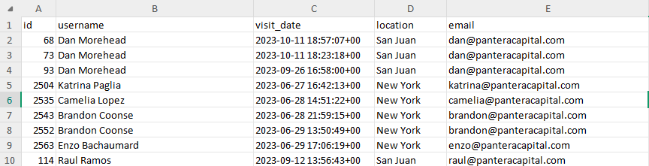

**Table Name: ACCESS_CARDS_EMAIL_MAP**

Snowflake Row Count: 120

Historical Export Row Count: 120

Column Matching?: Yes

Value Matching?: Yes

**Snowflake Records:**

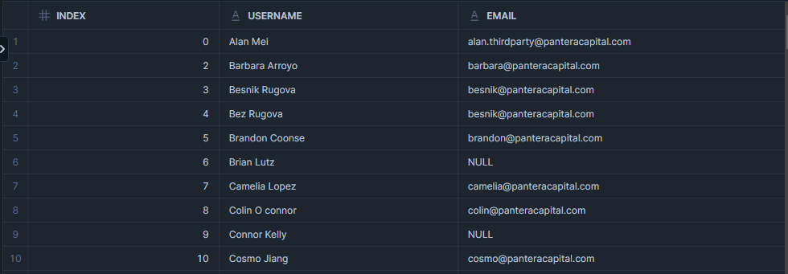

**Historical Export Records:**

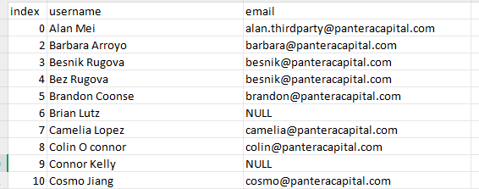

**Table Name: DEVICES**

Snowflake Row Count: 154

Historical Export Row Count: 154

Column Matching?: Yes

Value Matching?: Yes

**Snowflake Records:**

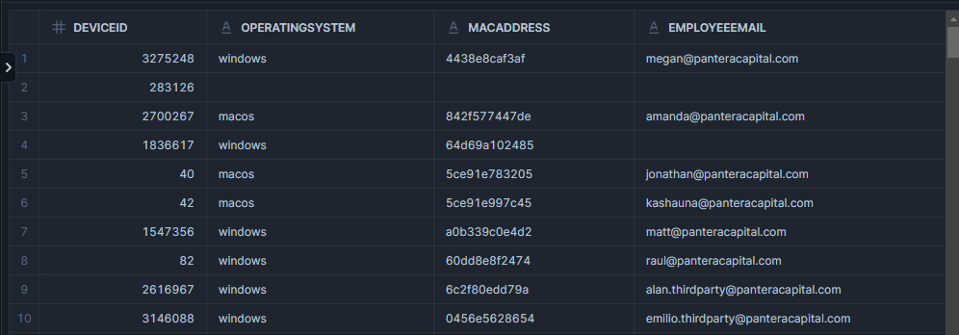

**Historical Export Records:**

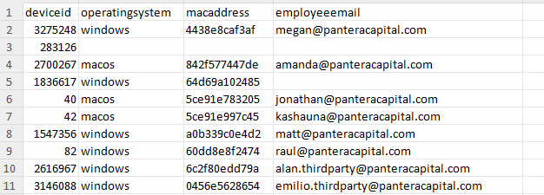

**Table Name: EMAIL_ACTIVITY**

Snowflake Row Count: 23116

Historical Export Row Count: 23116

Column Matching?: Yes

Value Matching?: Yes

**Snowflake Records:**

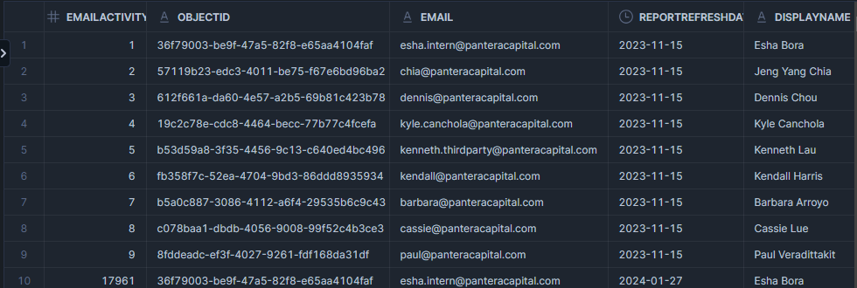

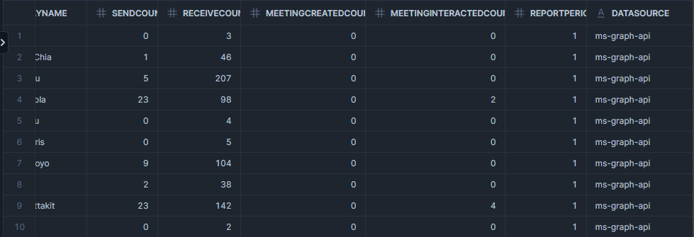

**Historical Export Records:**

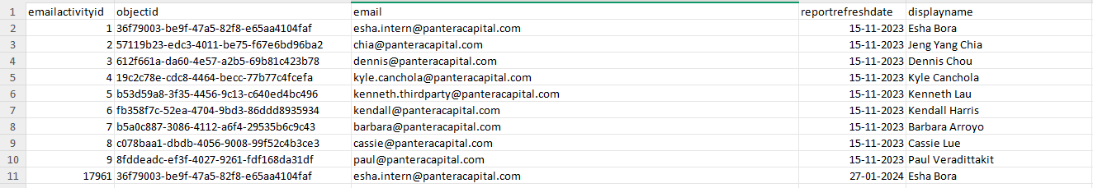

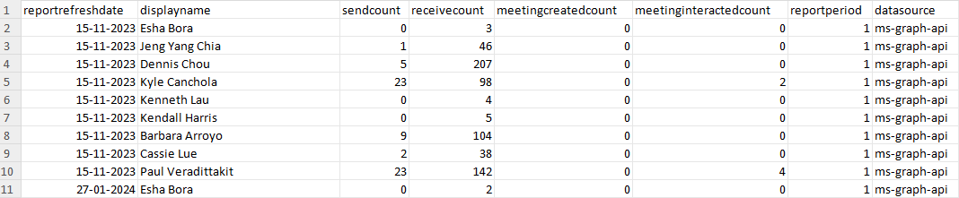

**Table Name: EMPLOYEES**

Snowflake Row Count: 125

Historical Export Row Count: 125

Column Matching?: Yes

Value Matching?: Yes

**Snowflake Records:**

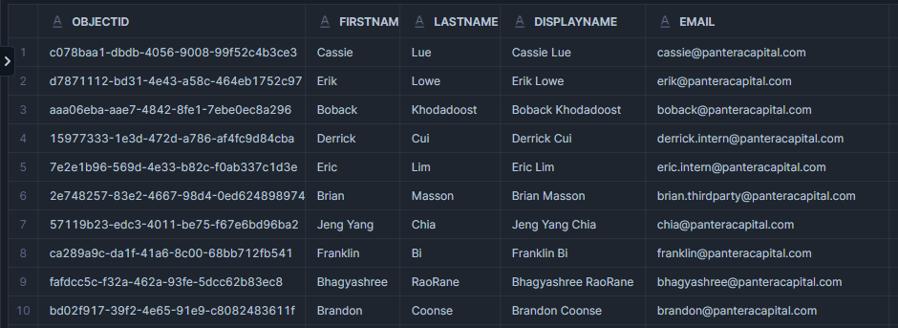

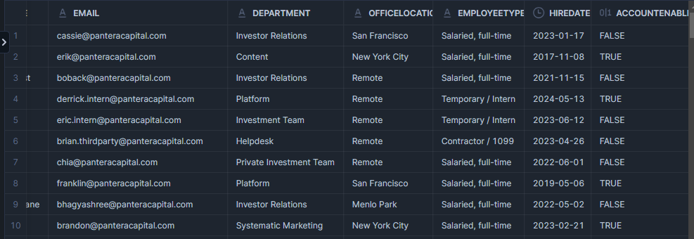

**Historical Export Records:**

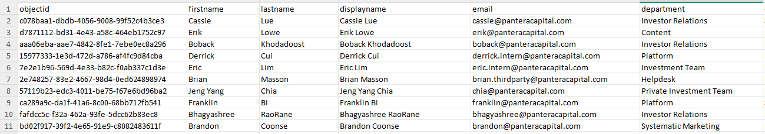

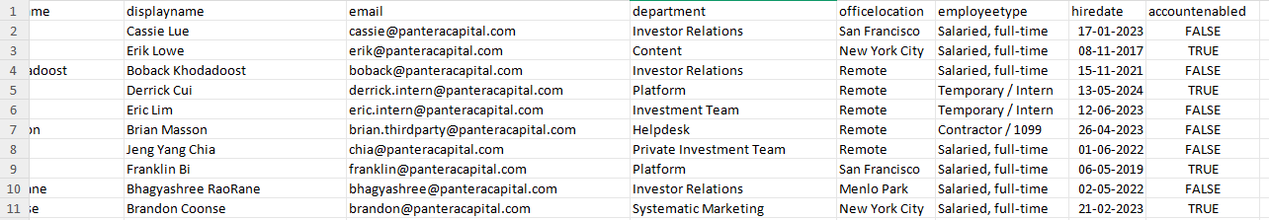

**Table Name: INTUNE_DATA**

Snowflake Row Count: 794552

Historical Export Row Count: 794552

Column Matching?: Yes

Value Matching?: Yes

**Snowflake Records:**

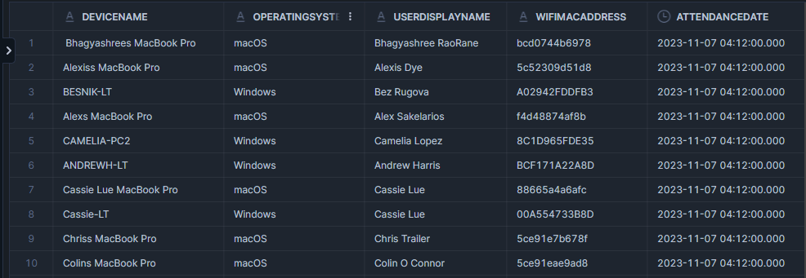

**Historical Export Records:**

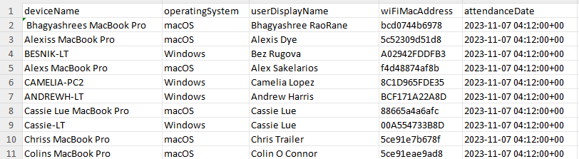

**Table Name: LOCATIONS**

Snowflake Row Count: 13

Historical Export Row Count: 13

Column Matching?: Yes

Value Matching?: Yes

**Snowflake Records:**

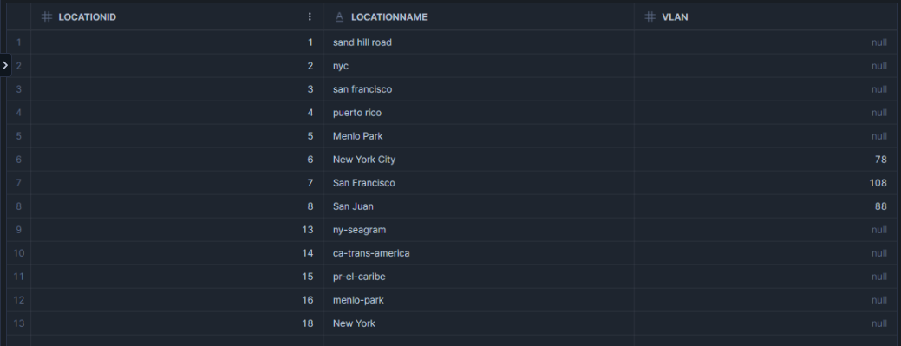

**Historical Export Records:**

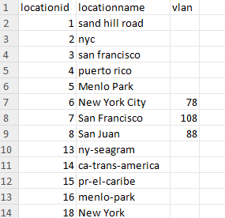

**Table Name: VISITS**

Snowflake Row Count: 330836

Historical Export Row Count: 330836

Column Matching?: Yes

Value Matching?: Yes

**Snowflake Records:**

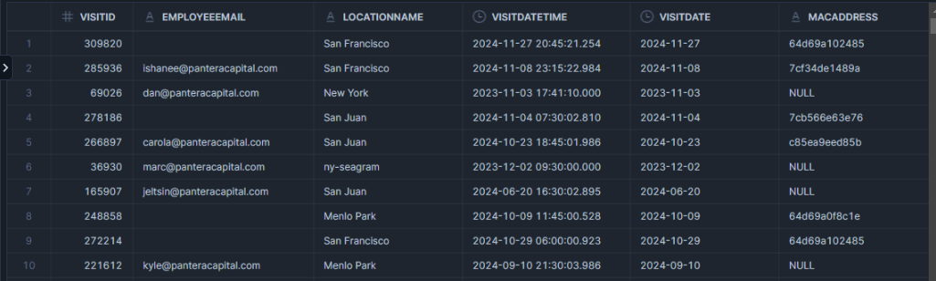

**Historical Export Records:**

